The Zionist movement has been instrumental in the establishment of a Jewish state on the land of Palestine. This idea, deeply rooted in Zionist thought, gained traction due to its call for a Jewish homeland. Key figures within this movement laid the groundwork for what would eventually become an internationally recognized state. To understand Zionism, one must examine the historical figures and their thoughts that shaped this movement.

One of the earliest proponents of this idea was Rabbi Jehovah Al-Kalai, a Jewish rabbi from a region near Yugoslavia. In 1839, he published a book outlining his views, which were steeped in Jewish mysticism and religious beliefs. He believed that the year 1840 would mark a turning point for the Jewish people, signaling that they should act to fulfill God's goals by moving to Jerusalem. Al-Kalai's views, while unconventional, sparked interest among Jewish communities.

Following Al-Kalai, other prominent figures emerged. Rabbi Zvi Hirsch Kalischer, another significant voice, wrote a book in 1862 titled "Drishat Zion" (The Search for Zion), advocating for the migration of Jews to Palestine. Kalischer's work highlighted the religious significance of the land and called for Jewish communities to take action. Alongside him, Moshe Hess, who wrote the book "Rome and Jerusalem," emphasized the need for Jewish nationalism and self-determination.

These early proponents of Zionism, despite differing in their approaches and beliefs, shared a common goal: the establishment of a Jewish homeland in Palestine. Their writings and teachings laid the foundation for the Zionist movement, which would gain momentum with the beginning of Jewish immigration from Russia in the early 1880s. This immigration, driven by persecution and the desire for a safe haven, fueled the Zionist movement's growth.

As the movement evolved, it faced challenges from within the Jewish community and from external sources. Traditional rabbis and religious leaders often viewed Zionism as heretical, believing that the Messiah would bring Jews to the Promised Land at the right time. Despite this opposition, Zionism continued to gain support, leading to the establishment of settlements in Palestine and the eventual formation of the State of Israel.

Theodor Herzl, a pivotal figure in modern Zionism, played a crucial role in bringing the movement to international attention. His book "The Jewish State," published in 1896, outlined the vision for a Jewish homeland and proposed a concrete plan for its establishment. Herzl's work was instrumental in uniting diverse factions within the Zionist movement and garnering support from Jewish communities worldwide.

Throughout the 20th century, the Zionist movement faced numerous challenges and controversies, with varying degrees of success. The international Zionist movement worked to achieve its goals through political means, religious teachings, and practical efforts to establish Jewish settlements in Palestine. These efforts eventually led to the declaration of the State of Israel in 1948, marking a significant milestone in Zionist history.

In summary, the Zionist movement's journey to establish a Jewish homeland was complex, involving a blend of religious beliefs, political strategies, and historical events. Despite opposition and setbacks, the movement's persistence and the efforts of key figures contributed to the realization of the Jewish state on the land of Palestine. Understanding the historical context and the motivations behind the Zionist movement provides insight into the ongoing complexities surrounding the Israeli-Palestinian conflict.

الحكايه

Imagine you're a seagull flying over the Mediterranean Sea, heading east until you reach a beautiful coastal area between Tel Aviv and Haifa. This region is home to a stunning spot called Dor, known for its golden beaches, coral reefs, and lush greenery. It's a popular resort, complete with amenities and a museum showcasing archaeological finds from the Bronze Age.

But as you continue flying, you notice something unusual. Amidst the modern resorts and stylish buildings is a single house, built in a traditional Arab style, standing out like a relic from the past. It's part of a story with a much darker past.

In 1991, a construction project began near this house to build a diving center. During excavation, workers found human bones buried at a shallow depth and immediately halted the project. The discovery drew the attention of Fouad Hasadiyeh, a fisherman from the nearby Arab village of Al-Faradis. When he inquired about the sudden stop, he was told that the bones were from Napoleon's era. But Fouad had a different story. He recalled his father's and grandfather's tales of a massacre in 1948, when Israeli soldiers killed and buried Palestinians in mass graves. One of these graves, Fouad claimed, was right beneath the parking lot of the Nahsholim resort.

The story of Dor, or rather the story of Tantura, a once-peaceful Palestinian village, is tragic. Until 1948, Tantura had about 1,500 residents, primarily dependent on fishing and farming. However, during the Nakba—the mass displacement and violence associated with the establishment of Israel—the village's men were gathered and executed by Israeli soldiers, while women were stripped of their valuables and expelled. The mass graves from that night are now hidden beneath modern structures.

For decades, this chapter in history remained unspoken. It wasn't until 1998, when an Israeli student named Teddy Katz published his master's thesis, that the story began to emerge. Katz interviewed soldiers from the Alexandroni Brigade, responsible for the assault on Tantura. Their testimonies revealed that what was officially called a "battle" was, in fact, a brutal massacre. Despite resistance, the villagers were poorly armed and had little chance against well-equipped soldiers. The testimonies of these soldiers, combined with research from groups like Forensic Architecture, have started to piece together the tragic history of Tantura.

Today, the story of Tantura stands as a reminder of the deep layers of history that can be found beneath the surface of modern resorts and idyllic beaches. It also serves as a testament to the resilience of those who survived, many of whom still live in Al-Faradis, just a few kilometers from where their families were killed and buried. While the story has been partially unearthed, much of the truth remains buried, much like the bones beneath the parking lot, waiting for more light to shine on a history that should never be forgotten.

The Israeli narrative employs a carefully constructed storyline to elicit sympathy and admiration while simultaneously framing key conflict points and presenting clear villains and heroes. Here's a detailed paragraph that explains how this narrative unfolds and the role it plays in shaping public perception:

The Israeli national story is crafted to win hearts and minds by invoking sympathy for a persecuted people while providing a compelling conflict with identifiable heroes and villains. The first antagonist in this narrative is the British Mandate, depicted as an obstacle to Jewish migration and state-building. By presenting the British as preventing Jews from escaping the Holocaust and finding safety in their "promised land," the story encourages the audience to root for the Jewish cause. As the plot develops, iconic figures like Menachem Begin, Yitzhak Rabin, Ariel Sharon, and Shimon Peres emerge as heroic leaders who confront the British and work towards establishing a Jewish state. These heroes, associated with military organizations like Haganah, Irgun, and Lehi, represent the struggle for freedom against oppressive forces.

By personifying these organizations as "freedom fighters," the narrative creates an immediate sense of solidarity with the Jewish cause, culminating in Britain's withdrawal and the UN's Resolution 181, which partitioned Palestine into separate Arab and Jewish states. The audience is led to cheer for the underdog, as the heroes ultimately prevail, leading to the formation of Israel with David Ben-Gurion as the first prime minister. However, the narrative takes a dramatic turn when a second villain emerges: the collective Arab forces from neighboring countries, portrayed as Goliath to Israel's David. According to this narrative, these seven Arab armies united to exterminate the newly formed Jewish state, transforming the Israeli struggle into a battle of survival. This simplistic yet compelling depiction not only elicits admiration for the Israeli heroes but also reinforces the idea that Israel is perpetually defending itself against existential threats.

This narrative structure—sympathy, admiration, and a clear conflict—serves to create a persuasive story that supports Israel's position in the world, often overshadowing the complexities and historical realities of the Palestinian experience.

Zionism emerged from the tumultuous context of late 19th-century Europe, where anti-Semitism and violence against Jewish communities were prevalent. Among those who advocated for integration was Theodor Herzl, an Austrian journalist raised in a secular Jewish family with minimal ties to religion. Herzl's turning point came while covering the trial of Alfred Dreyfus, a Jewish French officer accused of espionage. Amidst demonstrations in Paris, he reportedly heard chants of "Death to the Jews." This incident, though possibly exaggerated, prompted Herzl to question his earlier belief in integration and led him to explore a third option: Zionism.

Zionism, initially a Christian concept, evolved into a Jewish ideology advocating for the establishment of a Jewish state in Palestine. Herzl's form of Zionism was different from the earlier Christian interpretation, which had roots in Protestantism and anticipated the Second Coming of Jesus through the return of Jews to Jerusalem. Herzl's vision, however, focused on creating a Jewish state as a safe haven from persistent anti-Semitism. Despite his minimal religious connections, Herzl's Zionism was fueled by the belief that Jews needed a state of their own to protect themselves from non-Jews' deep-seated hatred.

Herzl documented his ideas in "The Jewish State," promoting a narrative that defined Jews as a unique and pure race, an approach inherently exclusionary and racist. This ideology rejected integration and aimed to create a Jewish state without non-Jews or, at least, with Jews as the dominant majority. Herzl faced resistance from Jewish communities in Europe, many of whom preferred to stay and demand equal rights rather than emigrate. Despite this resistance, the first Zionist Congress in 1897 declared Palestine as the destination for the Jewish state, transforming a biblical notion of diaspora into a modern political movement.

The Zionist narrative attempted to redefine Judaism and create a mythological story that blurred the lines between Zionism and Judaism. This narrative contributed to the misconception that anti-Zionism is synonymous with anti-Judaism. Herzl's approach to Zionism also promoted the myth of "a land without people," disregarding the existing Palestinian society's rich cultural diversity. This myth, along with the Zionist ideology's inherent exclusivity, laid the foundation for the conflict and controversies surrounding the establishment of Israel in the 20th century.

The Zionist project in Palestine, dating back to the late 19th century, was marked by immigration, land acquisition, and the development of settlements that often displaced Palestinians. Early attempts to gain a foothold were made during Ottoman rule, with Chaim Weizmann, a central figure in Zionist history, establishing a land development company in Jaffa. The company's purpose was to purchase land from Palestinians, but resistance grew as Zionists pursued a strategy to create a "land without people" by displacing Arab farmers.

Despite the Ottoman Sultan's initial refusal to allocate land for Jews, immigration continued, with the Jewish population in Palestine increasing from 24,000 to 50,000 before World War I. This growth in numbers, however, required a significant boost to establish a viable Jewish state, leading Zionist leaders to seek British support. Britain's interest in the region, driven by strategic considerations related to the Suez Canal and the broader colonial framework, aligned with the Zionist agenda.

In 1917, the Balfour Declaration, issued by British Exterior Minister Arthur Balfour, promised a national state for Jews in Palestine. However, the ambiguity of this promise raised questions about whether it implied a Jewish state with a Jewish-only population or simply a state with a significant Jewish presence. British support for Jewish immigration and settlement continued after World War I, culminating in the British Mandate over Palestine in 1920.

This mandate facilitated increased Jewish immigration, leading to the establishment of Jewish settlements with closed communities that did not integrate with Palestinians. The creation of local autonomy for Jewish towns, like Tel Aviv, and separate educational institutions contributed to the growing divide between Jews and Palestinians. The Palestinians' resistance to this process led to significant uprisings and revolts, such as the Buraq Uprising in 1929, where British forces brutally suppressed Palestinian resistance.

Churchill's White Paper in 1922 attempted to calm Arab concerns by suggesting that Jewish settlement would not lead to the occupation of Palestine, but rather the creation of a society that would work with the existing population. However, this assurance proved hollow as Jewish settlements continued to expand, often with exclusive Jewish labor policies that displaced Palestinian workers.

By the mid-1930s, Jewish immigration had increased the Jewish population in Palestine to 27%, a significant leap from the 3% at the end of the 19th century. Palestinian resistance and revolts against British colonization and Zionist settlement became more frequent, with figures like Izz al-Din al-Qassam emerging as leaders of armed resistance. His death in an unequal battle with British forces galvanized the Palestinian people, leading to a broader movement that would culminate in the 1936–1939 Arab revolt in Palestine. This revolt highlighted the growing tensions and resistance against the British mandate and Zionist aspirations.

The British were disoriented by the Great Arab Revolt, which sparked a significant reaction. They were likely surprised by the resistance, described metaphorically as "the dog in the manger." From 1936 to 1937, the British killed a thousand Palestinians and arrested anyone involved in the revolution, often demolishing their homes. In Jaffa alone, more than 200 houses were demolished.

Britain provided substantial support to Jewish settlers, facilitating their immigration and creating tightly knit Jewish communities with robust infrastructure. The British also combated Palestinian revolutions and often killed their leaders, leading to significant oppression and creating an environment where 10% of Palestinian men in 1940 were either killed, exiled, or arrested. Racist ideas were also propagated, and Britain encouraged the Zionist movement's colonial ambitions by helping develop a necessary military force.

The Peel Commission was established in 1937 to suggest dividing the land between one million Arabs and 400,000 Jews, proposing that one-third of the land would go to the Jews and two-thirds to the Arabs. This was seen as the beginning of the idea of expulsion, with suggestions to create ethnically and religiously unified areas by removing Arabs from the Jewish areas. The British supported Zionists' development of military power, leading to organized military structures like Haganah and other groups like Stern and Irgun.

The relationship between the British and Zionists deteriorated during World War II. Britain attempted to limit Jewish immigration to Palestine, causing tension and increasing resistance from Zionist groups. Zionist gangs like Irgun and Stern became more violent and organized, leading to terrorist acts like bombing markets, public places, and even British administrative buildings. British soldiers faced increasing hostility, and terrorism was used as a tool against the British themselves.

The Zionist movement began to seek a new ally as Britain started to lose its grip. This led them to the United States, which seemed more aligned with their aspirations. In 1942, the Baltimore Conference in the U.S. gathered Zionist supporters, emphasizing the need for a Jewish state and establishing strong ties with America. As British support waned, Zionist groups grew increasingly violent, leading to a shift in focus from expulsion to outright extermination and causing Britain to eventually hand the issue over to the United Nations.

The United Nations issued the Partition Resolution 181, dividing Palestine into six regions, three for Jews and three for Arabs, with Jerusalem under international supervision. Despite Palestinians being the majority population, owning 94% of the land and 80% of agricultural land, the partition allocated 56% of the land to the Jewish state. This led to significant discrepancies in land ownership and heightened tensions, as it seemed unjust to grant the minority a larger portion of the land, sparking further violence and conflict.

The main goal of Zionism was for the Jews to live without others who differ from them and the Zionist dream grew from a country in a part of Palestine to encompass the entirety of Palestine General D'Arcy once remarked that after Britain's withdrawal the Jewish Agency controlled all of Palestine The Haganah became an organized military group with 35000 soldiers while the Palmach command consisted of more than 10000 soldiers Irgun and Stern were also large and organized military groups with extensive experience Meanwhile the Arab front was disjointed and lacked systematic organization due to the Arab countries' recent recovery from war and occupation Their armies were exhausted and interests conflicted As a result the Arab countries established the Arab Liberation Army consisting of 4000 volunteers This unorganized army despite its loyal members struggled to coordinate its efforts Even within Palestine operations were scattered among leaders like Abdul Qader Al-Husseini Fawzi Al-Qawji and Hassan Salama who conducted separate actions with minimal impact

On the other hand the Zionist movement was intensifying its efforts in late 1947 The Villages Project collected information on all Palestinian villages which led to Plan Dalet a comprehensive ethnic cleansing plan in written form The plan was put into action on February 15 1948 when Yitzhak Rabin who would later receive a Nobel Peace Prize led an attack on the village of Caesarea in the Haifa district expelling 1500 inhabitants The Zionists attacked five villages to test the effectiveness of their fighters while ensuring British soldiers who remained in the region wouldn't interfere These attacks were part of a broader strategy to forcefully expel Palestinians

David Ben-Gurion once said that Israel's borders should be defined by the furthest reach of its soldiers reflecting the expansionist ideology of the Zionist movement The strategy involved besieging villages from three sides allowing one exit for villagers to flee or forcing them to become refugees In some cases these gangs would leave no exit such as in Deir Yassin on April 9 1948 where 250 people were murdered in a single day in front of their families The British police office just 3 kilometers away did nothing to intervene These terror tactics caused 75000 Palestinians to flee their homes in Jaffa Haifa and Jerusalem

As the British Mandate withdrew it handed over key infrastructure to the Jewish state including ports government buildings train stations and weaponized military camps The Zionist narrative claimed the Palestinian refugee crisis was caused by Arab armies advising residents to leave before they entered the historian Ilan Pappé however noted that half of the Palestinian refugees were expelled before May 1948 well before the Arab armies arrived Among the 530 villages destroyed in the Nakba half were ethnically cleansed before May 1948 demonstrating the premeditated nature of the expulsion

On May 14 1948 the State of Israel was established presenting itself as a young David facing a giant Goliath with major world powers quickly recognizing its legitimacy President Harry Truman recognized Israel after just 11 minutes The very next day Arab armies announced they would go to war but their total number of soldiers barely reached 25000 contrasting with the Zionist army's 35000 strong force By the end of the war the Jewish army's strength had grown to 100000 These were not just gangs but highly trained and well-funded forces armed by the Western countries performing organized military operations and massacres throughout the conflict

In August 1948 Count Bernadotte a UN ambassador visited Palestine and refugee camps in Jordan expressing his shock at the conditions he witnessed He called for justice and the right of refugees to return to their homes Unfortunately he was assassinated by the Stern gang with the participation of Yitzhak Shamir who later became the Prime Minister of Israel By December 1948 the Jews had occupied 85% of Jerusalem outside the old city despite UN oversight Israeli historian Hillel Cohen mentioned thousands of refugees from Sepphoris and nearby villages sought shelter in the Christian city of Nazareth which Ben-Gurion feared destroying given its significance to Christianity Palestinian Christians from other villages like Al-Bassa refused to return without Palestinian Muslims showing solidarity amidst the conflict

UN Resolution 194 issued in December 1948 guaranteed the right of return for all refugees expelled during the Nakba Unfortunately this resolution was never implemented Meanwhile in 1950 Israel announced the Law of Return allowing any Jew to return to Israel regardless of their ancestral connections This double standard contrasted with the reality of Palestinian refugees unable to return to their ancestral lands even if they lived just across a river such as in Jordan The ideology behind the Law of Return originated from Herzl advocating for a pure Jewish society without others This ideology persisted leading to the expansionist and often violent actions of the Zionist movement

By the time of the Peace Treaty in July 1949 Zionist forces had not only taken control of 55% of the land outlined in the Partition Resolution but 78% of the total land the UN acknowledged these new borders calling them the Green Line Israeli historian Theodore Katz noted that the Israeli Defense Force's morality rested on a false narrative as they did not enter a land without people but one with 1.3 million Palestinians These narratives continue to shape the Israeli-Palestinian conflict with denial and justification mechanisms supporting the expansionist policies pursued by the Zionist movement throughout its history.

Israel's current leader, Benjamin Netanyahu, once stated that Israel is not a state for all its citizens but rather the nation-state of the Jewish people and only them. This perspective reflects the complex realities for Arabs living on the historical land of Palestine. Life for them is significantly shaped by their geographic location, categorized into three groups: the 1948-Palestinians, West Bank Palestinians, and Palestinians of Gaza.

The 1948-Palestinians, about two million with Israeli citizenship, constitute roughly 20% of the country's population but are treated as second-class citizens. They experience lower educational opportunities because the Arabic spoken by these two million Palestinians is not officially recognized in Israel. Additionally, even when they attain high positions in their careers, their income typically remains below that of other Israeli citizens. This group also faces restrictions on bringing family members from outside Israel, and if they wanted to convert to Judaism, Israeli law imposes significant barriers.

The situation for West Bank Palestinians is even more challenging. About 2.7 million live under direct Israeli occupation in a prison-like structure with locked gates and numerous military checkpoints. The area is also surrounded by more than 130 settlements, considered illegal by international standards. From 2017 to 2021, while the Israeli army issued 33 permits for Palestinians to build homes, it demolished over 1,150 Palestinian homes and granted over 1,100 building permits to settlers. Palestinians who lose their homes often have no place to go, and even setting up a tent requires a permit they rarely get.

Palestinians in Gaza endure the harshest conditions. About two million people live in a fully besieged area of 360 square kilometers with no access to ports, airports, or trains. The region's water is heavily polluted, with only 10% of it deemed suitable for human consumption. Electricity is intermittent, with only 200 of the 560 megawatts needed to sustain the strip's energy requirements. This leads to significant hardship and contributes to high unemployment rates, with about 50% of the population without work. Gaza's educational infrastructure is also severely compromised, with many schools destroyed in previous conflicts.

Overall, the Israeli-Palestinian conflict is marred by structural inequalities and human rights violations. Human Rights Watch, Amnesty International, and other organizations have documented and criticized Israel's apartheid policies. The impact of these policies goes beyond mere discrimination, affecting everyday life, economic opportunities, and basic human rights for Palestinians living in different parts of the territory. These realities have roots in historical events and complex geopolitical interests that continue to shape the region's future.

In 1942, Zionists held the Baltimore Conference to gather supporters of Zionism in the United States Among its recommendations was that the new world, born after the war, would include a Jewish state with its arms wide open to all Jews globally This period marked the Zionist movement's effort to align itself with the interests of the world's greatest empires, presenting itself as a solution for the European Jewish surplus and as an ally to the United States, which remained largely unaffected by war The US accepted the role of the new sponsor, a sentiment echoed by former presidential candidate Hillary Clinton, who stated that Americans, being mostly immigrants seeking a dream in a distant land, could empathize with the Zionist dream In her diary, "Hard Choices," Clinton noted, "In Israel’s story, we see our own" This notion of shared ideals and the strategic benefits of having an ally like Israel in the Middle East solidified the alliance between the Zionist movement and the US, resulting in significant funding, including for Haganah's armament factories

The shift in support from Britain to the US shocked the British, who felt their long-standing investment in the Zionist project had resulted in betrayal The British, who had invested in Zionism to serve their interests in the region, were stunned to discover that the Zionists had been nurturing their own ambitions Britain, initially expecting control over the movement, found itself facing a violent backlash In 1946, the Irgun gang blew up the King David Hotel, the British Administration headquarters, with nearly 200 kilograms of explosives, killing 91 people In 1947, the Irgun bombed the British Officers' Club in Jerusalem, signaling that the Zionists no longer needed British support Britain’s strict immigration policies, refusing entry to Holocaust survivors aboard the ship Exodus, further strained relations, leading to violent retaliation by Zionists, including the hanging of two British soldiers

Despite these attacks, the British did little to counter the Zionist insurgency, instead arresting over 300 Palestinians on charges of carrying weapons Avi Shlaim, an Israeli historian, highlighted the paradox in British policy, pointing out that the British mandate bore the moral burden of opposing and precluding the establishment of a Palestinian state, leading to their decision to hand over the matter to the United Nations in 1947, effectively saying, "You solve this issue; I've had enough!"

The UN's Partition Resolution 181, issued in 1947, divided Palestine into six regions, with 56% allocated to the Jewish state, despite Palestinians owning 94% of the land and constituting double the population of the Jews The resolution was seen as unfair by the Palestinian majority, with Zionists benefiting from a larger share despite holding only 6% of the land prior to the partition The ensuing conflict saw Zionist military groups like Haganah, Palmach, and Irgun engaging in aggressive operations, while Arab and Palestinian forces lacked organization, with scattered efforts led by separate leaders such as Abdul Qader Al-Husseini, Fawzi Al-Qawji, and Hassan Salama

At this time, Zionist leaders began implementing Plan Dalet, a blueprint for ethnic cleansing designed to ensure a homogeneous Jewish state The plan's trial run, led by Yitzhak Rabin, involved attacks on Palestinian villages, including Caesarea in the Haifa district, expelling 1500 residents This marked the beginning of systematic ethnic cleansing, laying the groundwork for further violence and the eventual establishment of the state of Israel The violent shift, driven by the Zionists' organized military strength, ultimately led to the 1948 Arab-Israeli War, with Britain withdrawing and leaving the region to contend with escalating conflict and instability.

The gangs began to organize attacks on the villages surrounding Jerusalem. Someone asked, "Wasn't Jerusalem not a part of the partitioned areas? I just saw that map you showed me!" My friend, David Ben Gurion, was once asked about Israel's borders. He said the best definition for Israel's borders is the farthest place that Israeli soldiers can get to. Since the beginning of the Zionist movement, it has been a movement that takes a piece of land and keeps expanding. "I mean, why commit to borders that weren't set when we arrived? We're the ones who set those borders, and those borders are created and changed every day." This ideology has controlled the Zionist movement from its birth till now.

In the beginning, the strategy was besieging every village they encountered from three sides, leaving only one exit for the villagers to leave and become refugees elsewhere. "Where would they go? It's their problem." However, sometimes these gangs would need to show off their power by leaving no exit for escape, as happened in Deir Yassin on April 9, 1948. Deir Yassin was a tranquil village with about 700 residents, including farmers, merchants, a mosque, two schools, and a sports club. In just one day, 250 people were murdered, almost a third of the village. Each person would see their family die in front of their eyes, knowing they were next. Despite the British Police Office being only 3 km away, none of them did anything. This terror demonstration forcibly pushed 75,000 Palestinians to leave their homes in Jaffa, Haifa, and Jerusalem.

The ethnic cleansing did not just involve expulsion and eradication but also erasing any memory of that place, as if those victims were never there. One kilometer away from Deir Yassin, Yad Vashem was built, a holocaust museum. It’s a stark contrast. While the gangs were seizing villages by force, the British Mandate handed over the ports to the Jews as it left, along with around 2,700 government buildings, 50 train stations, 3,000 km of roads, and 37 camps equipped with weapons and spare parts. The British literally built the Zionists a country and left.

According to the Zionist narrative, the crisis of the Palestinian refugees was caused by Arab armies calling citizens to move in preparation for armies to enter. However, historian Ilan Pappé says that half of the Palestinian refugees were expelled from their homes before the war even started, before May 1948, before the Arab armies even set foot. Among the 530 villages destroyed in the Nakba, half of them were ethnically cleansed. The historian Avi Shlaim confirms that the refugee crisis began during the first half of 1948, but was not caused by the war itself.

On May 14, 1948, the establishment of the State of Israel was announced. As part of the narrative, it announced itself as a young David in front of a giant Goliath, in a time when all the giants of the world, its Great Powers, recognized it very quickly. So much so that for a country like America, President Harry Truman recognized Israel after only 11 minutes. The very next day, on May 15, 1948, Arab armies announced they would go to war, and the New York Times published a headline: "Jews in Grave Danger in All Muslim Lands." If you reflect on that title, it takes advantage of the Holocaust. It was a rising state with ready-to-go propaganda.

While the headline implied a Jewish minority facing a huge tide of Muslims, if you looked a bit closer, you’d find that the entire seven Arab armies had only about 25,000 soldiers. These armies weren’t regular armies; some of these countries were still under occupation. On the other side, the Jewish army started the war with 35,000 soldiers, and by the end of the war, they had 100,000 soldiers. The Arab countries thought they were facing a group of gangs, not well-trained and funded armed forces. This misjudgment was a key reason for their defeat.

After the defeat of the Arab armies and the expulsion of hundreds of thousands of Palestinian refugees to surrounding countries, UN ambassador Count Bernadotte visited Palestine and refugee camps in Jordan. He was horrified by what he saw and said, "It would be an insult to the principles of justice to deprive these innocent victims of the right to return to their homes." But the Stern gang assassinated Bernadotte, with Yitzhak Shamir's involvement, who would later become the Prime Minister of Israel.

By December 1948, the Jews occupied 85% of Jerusalem outside the old city in front of the eyes of the UN. The Israeli historian Hillel Cohen stated that thousands of refugees from Sepphoris and the surrounding villages took shelter in the Christian city of Nazareth. Ben-Gurion feared destroying it due to its significance to Christians, as it is the city of Jesus. These refugees became the nucleus for the 1948-Arabs, the Palestinians within the new state to be established.

The UN issued Resolution 194, guaranteeing the right of return for every refugee expelled during the Nakba. However, this right was never implemented. On the other hand, in 1950, Israel announced the "legendary right of return," allowing any Jew to return to Israel. It's ironic that someone with a Jewish mother who never lived on the land could "return" to it and get citizenship, while a Palestinian refugee from across the Jordan River couldn’t cross to his ancestral land. This idea culminated from Herzl's concept of creating a pure-race society for Jews only.

When the Peace Treaty was signed in July 1949, the Zionist forces had taken over 78% of the land, even though the Partition Resolution had given them 55%. The UN acknowledged these new borders and called them the "Green Line." Israeli historian Theodore Katz noted that the Israeli army didn’t come to a land without people, but to one with 1.3 million Palestinians, whom they didn’t view as humans. This dehumanization was part of the inherited legacy for new generations in Israel, relying on a fictional narrative to justify their actions.

Israel, under Benjamin Netanyahu's leadership, continued to affirm that it is not a state of all its citizens, but rather a nation-state for Jewish people alone. If you're an Arab living in the historical land of Palestine, your life is determined by which category you fall into: the 48-Palestinians, West Bank Palestinians, or Palestinians in Gaza. The 48-Palestinians are second-class citizens, making up 20% of the country but facing discrimination and fewer opportunities for education. The Arabic they speak is not officially recognized, reinforcing their marginalized status.

Even if they attain high ranks at work, their income still lags behind the average Israeli citizen. If they attempt to focus solely on personal matters and family, they face further barriers—they cannot request citizenship for family members living outside Israel. Should they choose to abandon their heritage and convert to Judaism, they encounter legal obstacles that render the process nearly impossible. Life is hard for these Palestinians, yet their struggles are minor compared to those in the West Bank, where 2.7 million Palestinians live under direct Israeli occupation.

The West Bank resembles a labyrinthine prison, with segmented sectors and locked gates. Moving between sectors requires navigating a multitude of military checkpoints, turning a simple journey into an ordeal. Within a single street, there can be dozens of checkpoints, causing hours-long delays. Additionally, the West Bank is encircled by more than 130 illegal settlements housing over 500,000 settlers. Between 2017 and 2021, the Israeli army issued only 33 building permits to Palestinians but demolished over 1,150 homes and granted 1,100 permits to settlers. Palestinians whose homes are demolished cannot even set up a tent without army approval, which is rarely granted.

The Israeli army's control extends to basic necessities. Water distribution is severely limited for Palestinians, with settlers receiving 300 liters per day while Palestinians manage with just 80 liters—far below the 100-liter threshold specified by the World Health Organization. In Gaza, the situation is even worse, with 2 million people confined to a besieged area of just 360 square kilometers. There are no ports, airports, or trains; nothing enters or leaves without Israeli army permission. Reports suggest the army controls the calorie intake of Gaza residents, restricting food and other essentials. Groundwater is contaminated, with 90% deemed unsuitable for human consumption or farming. Unemployment in Gaza stands at 50%, and electricity is available for only a few hours a day, exacerbating the dire conditions.

The plight of Gaza’s children is particularly concerning, with many schools destroyed and limited opportunities for education. The International Committee of the Red Cross views Gaza as a violation of the Geneva Conventions, akin to a large open-air prison. Israeli academic Oren Yiftachel describes Israel as an ethnocracy, a system designed to serve the Jewish majority while undermining the Arab minority. This view is supported by leading figures like Noam Chomsky and organizations like Human Rights Watch and Amnesty International, all labeling Israel as an apartheid state.

The original Zionist ideology, which centered on a Jewish-only state, has evolved into systemic discrimination against Palestinians. Despite being second-class citizens in their own land, Palestinians continue to struggle for their rights and recognition. The prevailing attitude is that identity determines rights, leading to a society structured on racial and religious segregation. This unfortunate reality underscores the need for a better future, where human rights and dignity are universally recognized, and the Palestinian people can live in peace and equality. Through understanding the complex history and present-day struggles, perhaps we can imagine a world that prioritizes justice and humanity for all.

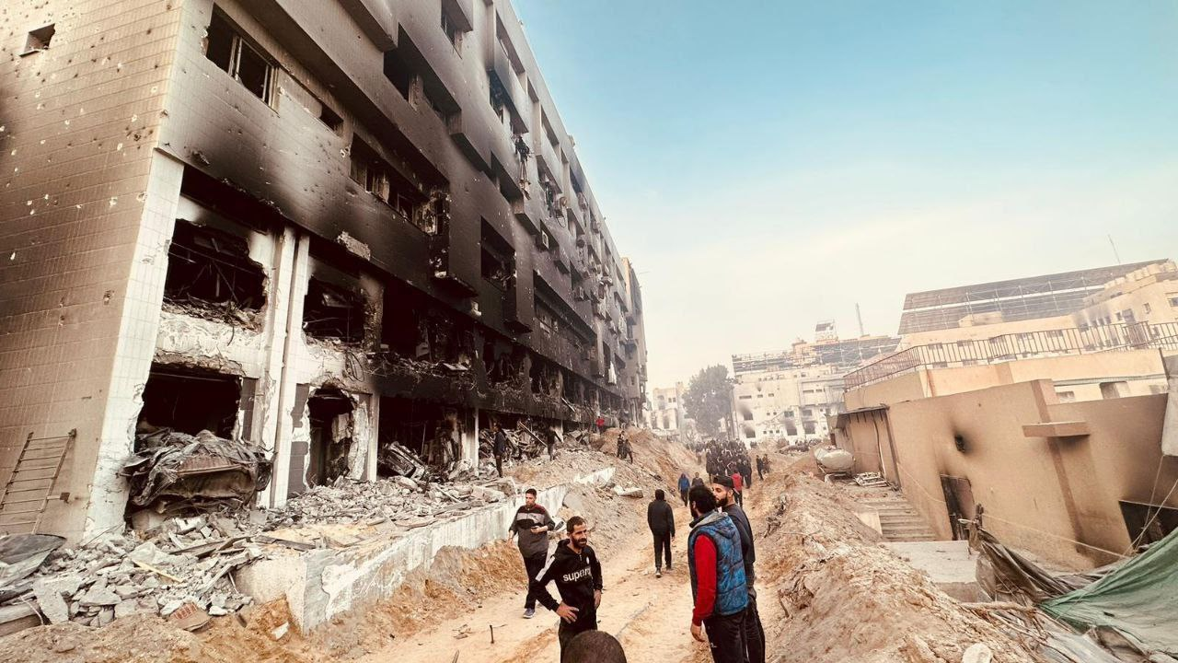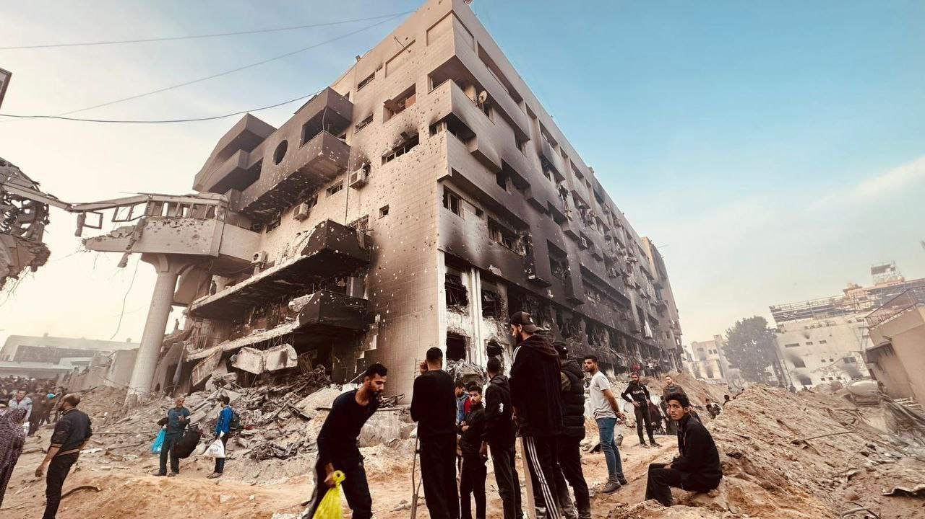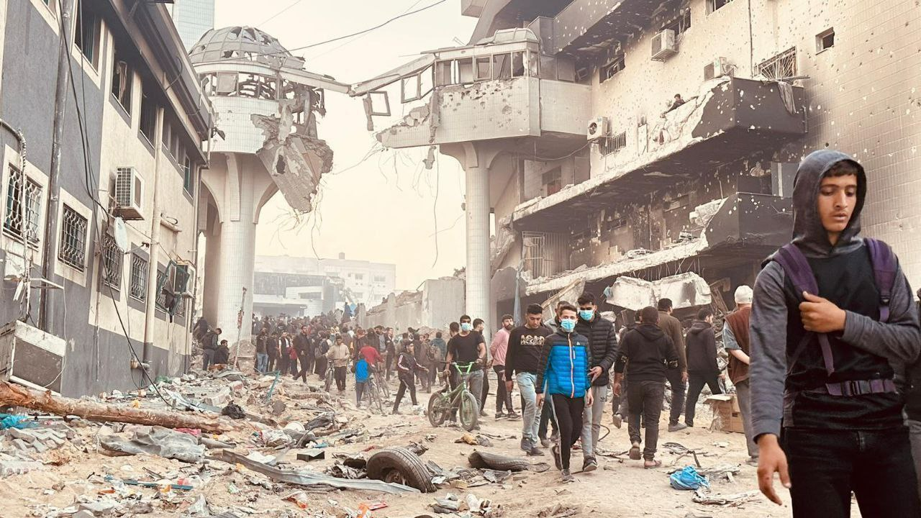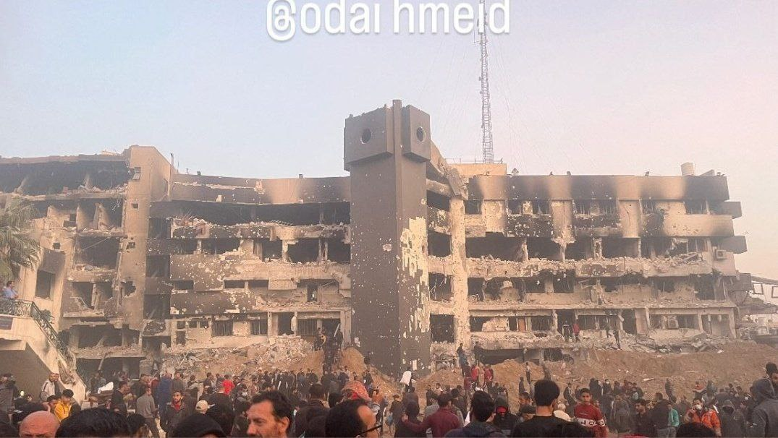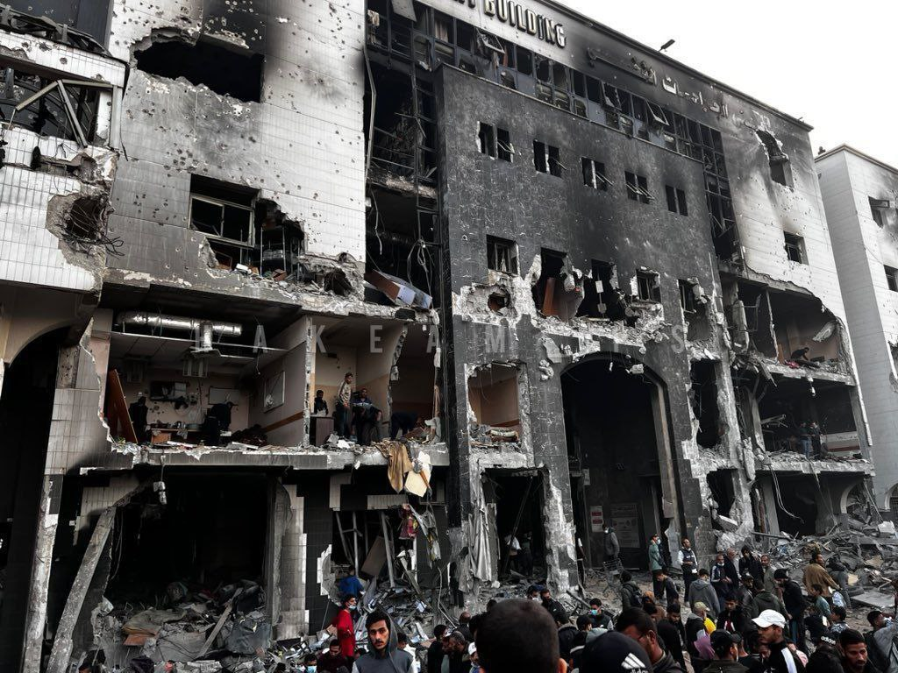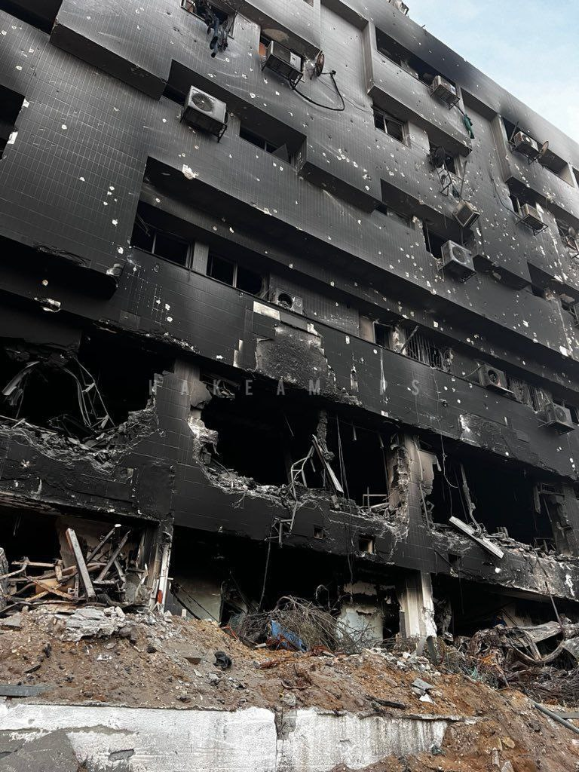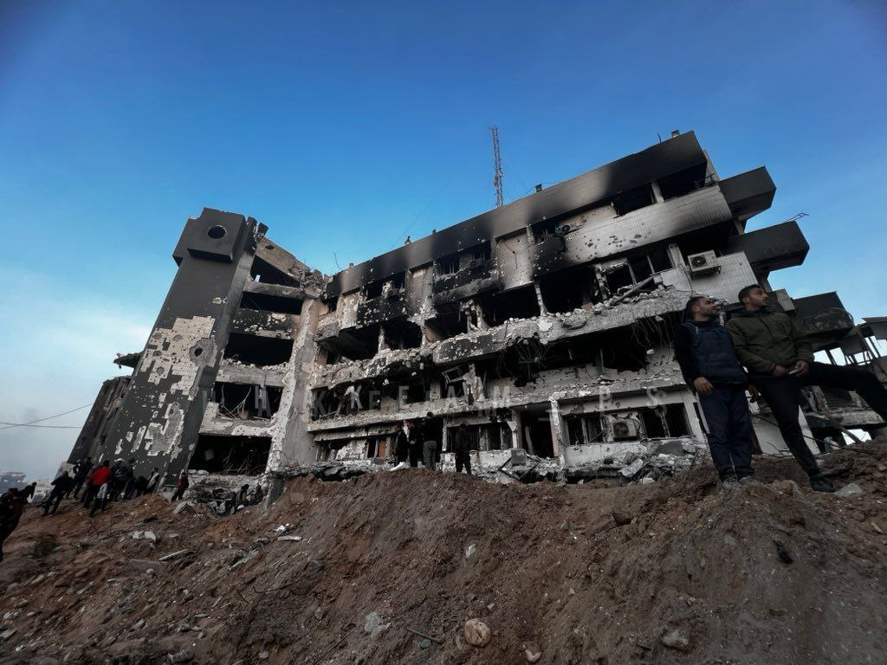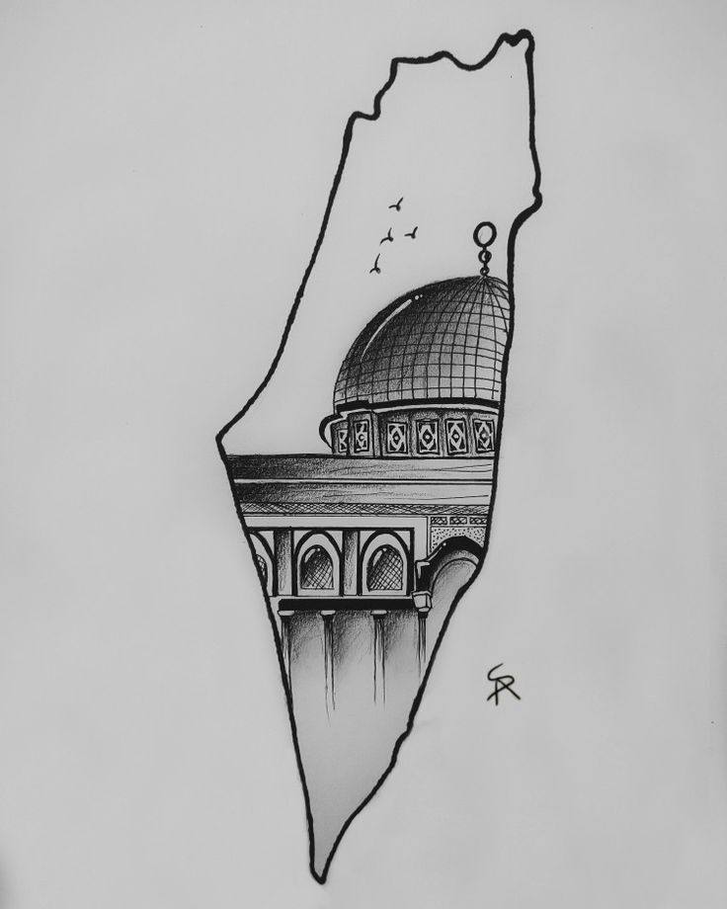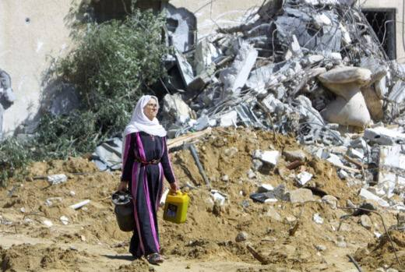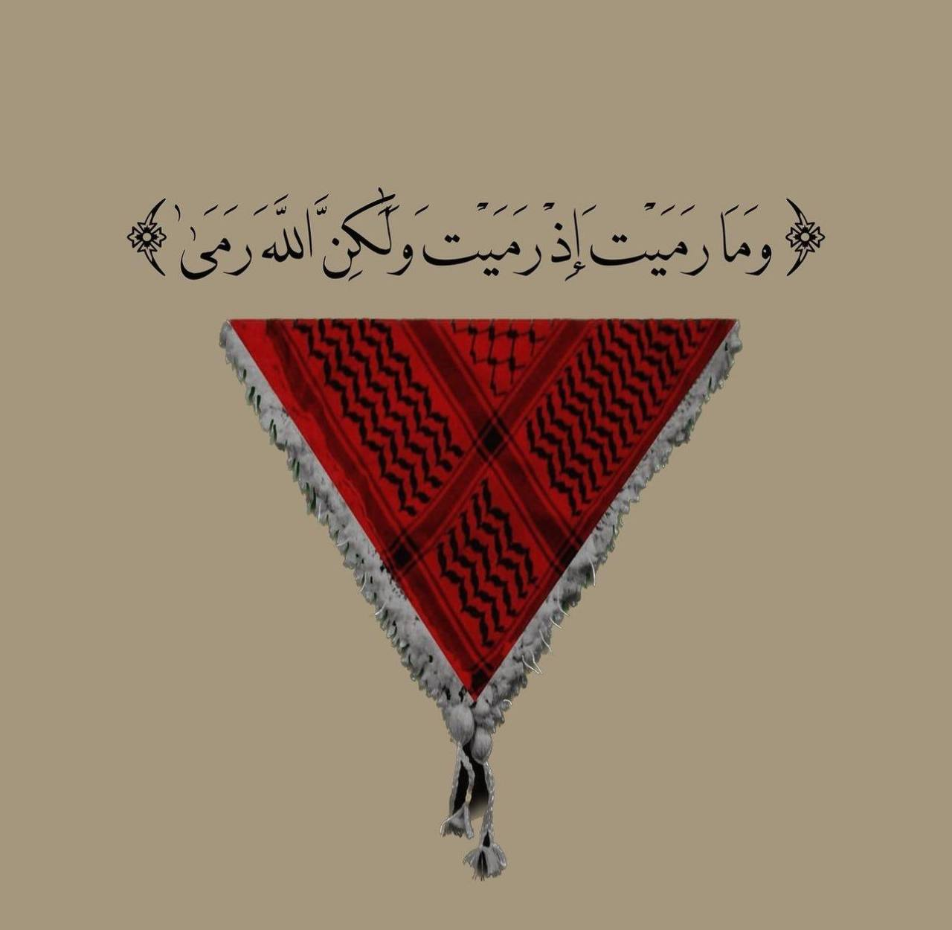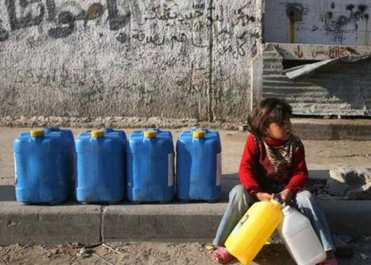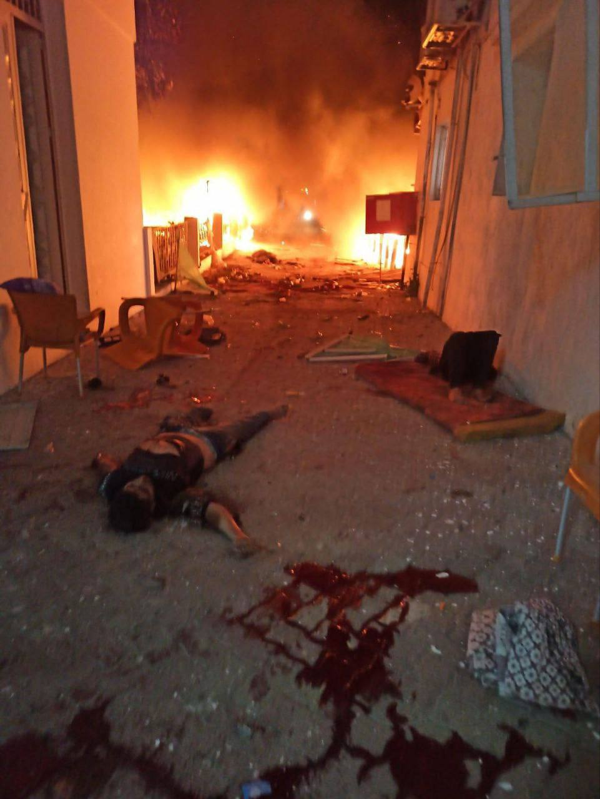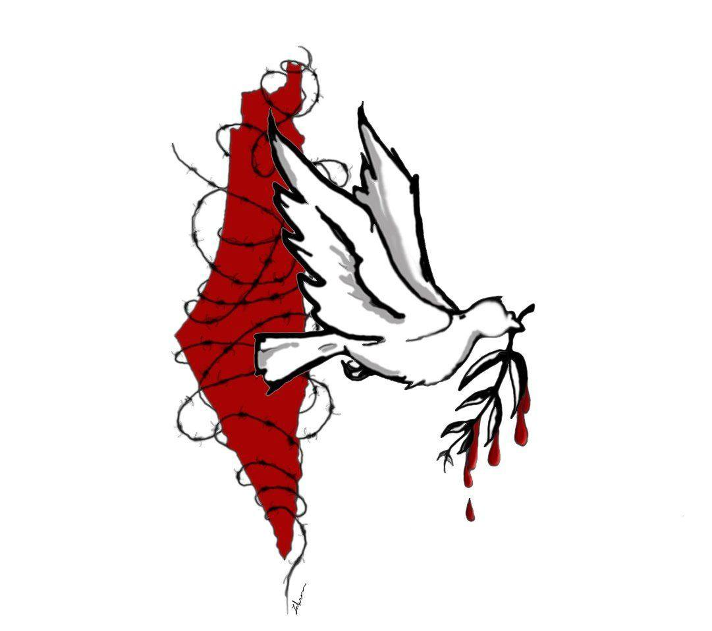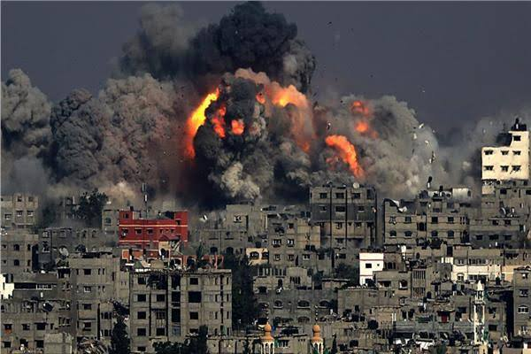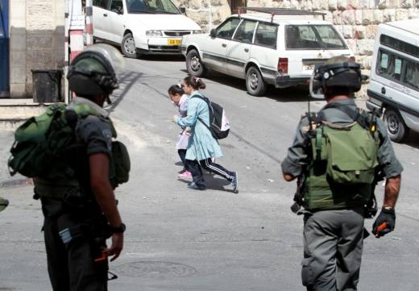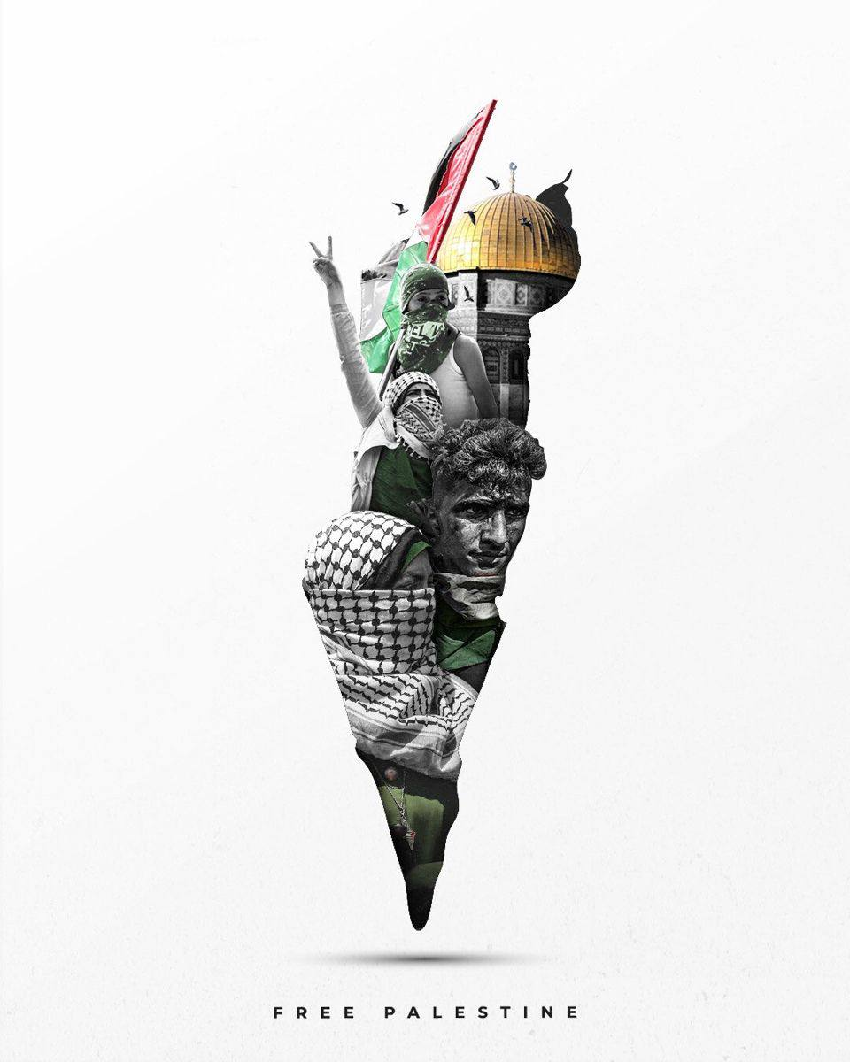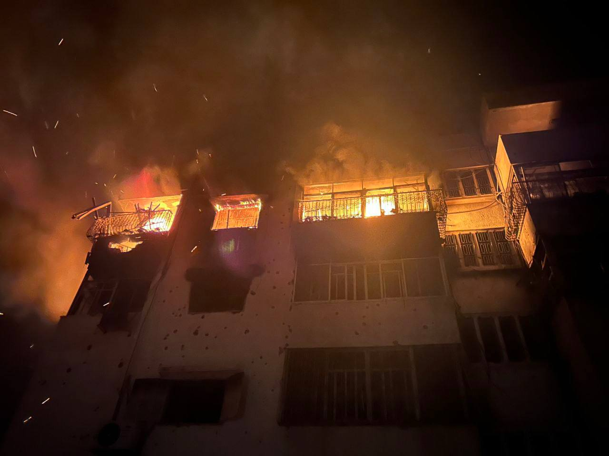

حادثه البراق

The “Buraq Revolution” is considered the first Palestinian uprising against the attempt to Judaize Jerusalem, as large-scale clashes broke out between Arabs and Jews at the Buraq Wall (the western wall of Al-Aqsa Mosque) on August 15, 1929, and the revolution reached its climax on August 23, 1929, with Dozens of martyrs and wounded .

At the beginning of the 20th century, the British Mandate changed the features of Jerusalem with the aim of establishing a national homeland for the Jews in Palestine, with Jerusalem as its capital, based on the Balfour Declaration in 1917 .

After about 10 years of British rule, the “Zionists” organized large demonstrations at the Buraq Wall, claiming that it was a place reserved for Jews alone. This sparked the first Palestinian revolt against Britain and the Zionist movement together .

The outbreak of revolution

The Buraq Revolution broke out when the Jews organized a huge demonstration at the Buraq Wall on August 14, 1929, on the occasion of what they called “the anniversary of the destruction of the Temple of Solomon,” claiming that it was a special place for Jews alone .

The next day, August 15, 1929, they followed it with a huge demonstration in the streets of Jerusalem, until they reached the Buraq Wall, where they started shouting “The wall is ours” and chanting the “Zionist national anthem” in conjunction with cursing Muslims .

The British police knew about the demonstration in advance, and sent large forces to escort the Jewish demonstrators .

On the third day, Friday, August 16, which coincided with the anniversary of the Prophet’s birthday, Muslims flocked to defend the Buraq Wall, as the Jews intended to seize it, and violent clashes occurred between the two sides that spread throughout most of Palestine .

The revolution witnessed clashes between the Palestinians on the one hand and the Jews and the Mandate forces on the other hand in Hebron, Safed, Jerusalem, Jaffa and other Palestinian cities, and it continued for days .

The confrontations resulted in the killing of 133 Jews and the wounding of 339 others, while 116 Palestinians and Arabs were killed and 232 others were wounded .

After Britain was able to control the situation harshly, it put more than a thousand Arabs and Palestinians on trial and 27 of them were sentenced to death, including one Jew who was a policeman who entered an Arab family in Jaffa consisting of 7 people and killed them all .

The Mandatory Authority commuted the sentences to life imprisonment against 23 Palestinians, and upheld the death sentence against 3 after they were accused of killing Jews: Fuad Hassan Hijazi, Muhammad Khalil Jamjoum, and Atta Ahmad Al-Zeer, who were executed on June 17, 1930, in the city prison. Acre is known as (the Citadel), and because the three martyrs were executed on Tuesday, it was called “Red Tuesday . ”

British decree

In an attempt by Britain to prevent the recurrence of another revolution similar to the Buraq Revolution, on October 25, 1929, the Mandatory Authority issued a decree called the “Penal Code (Crimes of Sedition) . ”

Following the events of the Buraq Revolution, the Council of the League of Nations decided on January 14, 1930, to urgently form a committee whose names were proposed by the British government, and to assign it to decide “the question of the rights and claims of Muslims and Jews at the Wailing Wall (Al-Buraq) .”

On December 1, 1930, the committee concluded that the ownership of the Buraq Wall belongs to the Muslims, and they alone have the real right to it. It also saw that the Western Wall is an integral part of the Holy Mosque Square, which is the property of the endowment .

She added that Jews have the right to free access to the Western Wall to perform supplications (prayers) at all times, subject to a number of conditions. In fact, the committee approved the status quo that prevailed during the Ottoman era .

Shaw commission report

On March 12, 1930, the “Shaw Committee” (a British investigation committee headed by Sir Walter Shaw) published its report on the events of the Buraq Wall. It saw that Zionist immigration and practices related to land purchases were the main cause of the unrest, pointing to “the Arabs’ double fear that they would They will be deprived of their means of livelihood, and one day politically controlled by the Jews due to Jewish immigration and land purchases . ”

At the same time, the Shaw Committee expressed its support for the issuance of the Penal Code (Sedition Crimes) Decree in October 1929, that is, two months after the Buraq Revolution .

On May 2, 1930, the British Colonial Secretary, Lord Passfield (known as Sidney and Web), sent Sir John Hope Simpson to Palestine in order to consult with the High Commissioner and to consider on the ground the issues of immigration and land settlement and development .

Passfield aimed to calm the protests of the Jews and their supporters who had expressed their rejection of the results of the Shaw Commission report, and demanded the formation of an investigation committee and to continue examining the issue of land and immigration .

Sentencing and executions

The British Mandate authorities imprisoned many Arab activists, and the British courts in Palestine issued death sentences against twenty Arabs. The sentence was later converted to life imprisonment, with the exception of three of them (Ata al-Zeer, Muhammad Jamjoum, and Fuad Hijazi), who faced hanging in Akka Prison on Tuesday, June 17, 1930, with courage. .

As for the Jews, only one of them was sentenced to death, then it was reduced to ten years and he was released after spending a short period of time .

